HandsMen Threads Salesforce Project Documentation

Salesforce Platform Developer Project

Contents
No. | Contents
1 | Project Overview
2 | Objectives and Implementation Scope
3 | Requirement Analysis and Data Model
4 | Formulas and Data Quality
5 | Salesforce Configuration and Data Security
6 | Email Templates and Alerts
7 | Process Automation using Flow
8 | Automation using Apex Triggers
9 | Batch Apex and Scheduled Processing
10 | User Interface and Sample Records
11 | Functional Testing and Results

This report presents the HandsMen Threads Salesforce implementation in a concise review format. Each numbered figure panel identifies the exact screenshot that should be captured from the Salesforce developer org before submission.

HandsMen Threads: Elevating the Art of Sophistication in Men's Fashion

Project Overview
HandsMen Threads is a Salesforce CRM solution developed for a fashion industry organization to manage customer, order, product, inventory, and marketing information in a centralized system. The solution focuses on maintaining data accuracy, improving customer engagement, and automating repetitive business processes.
The CRM provides a structured data model connecting customers, orders, products, inventory, and marketing campaigns. Salesforce automation is used to handle order confirmations, low-stock notifications, loyalty status updates, and scheduled inventory processing.
The project combines Salesforce configuration and development features including custom objects and fields, relationships, formula fields, validation rules, profiles, roles, permission sets, Record-Triggered Flows, Scheduled Flows, Apex Triggers, and Batch Apex.

Area | Salesforce Feature
Data | Custom objects, custom fields, formula fields, relationships
Automation | Record triggered flows and scheduled flow
Development | Apex classes, triggers, handler pattern, Batch Apex, Scheduled Apex
Security | Profiles, roles, users, permission sets, object access
Communication | Classic email templates and email alerts

Objectives
The primary objectives of the HandsMen Threads CRM are:
- To create a centralized Salesforce platform for managing business data.
- To establish relationships between customers, orders, products, inventory, and marketing campaigns.
- To maintain data quality through validation rules and formula fields.
- To automate customer communication through order confirmation and loyalty emails.
- To provide proactive inventory management through low-stock alerts.
- To automate inventory restocking using Batch Apex and Scheduled Apex.
- To implement appropriate user access and security using profiles, roles, and permission sets.
- To improve operational efficiency by reducing manual business processes.

Area | Included Implementation | Review Evidence
Data model | Five custom objects with business fields and relationships | Object Manager and Schema Builder
Data quality | Formula fields and validation rules | Field and validation rule screens
Security | Profile, role hierarchy, users, permission set | Setup security screens
Automation | Order, stock, and loyalty flows | Flow Builder canvases
Development | Handler, triggers, batch, and scheduler | Apex class and trigger screens
Testing | Sample records, error messages, updates, and emails | Lightning records and test results

Implementation Details

Data Model
The Salesforce data model consists of the following custom objects:

Custom Object | Key Fields | Business Purpose
HandsMen Customer | Name, First Name, Last Name, Email, Phone, Loyalty Status, Total Purchases | Stores customer identity, contact, and loyalty details.
HandsMen Product | Name, SKU, Price, Stock Quantity | Stores the product catalogue and pricing.
HandsMen Order | Order Number, Status, Quantity, Total Amount, Customer, Product | Captures customer purchases and order status.
Inventory | Inventory Number, Warehouse, Stock Quantity, Product | Tracks stock levels for each product.
Marketing Campaign | Campaign Number, Start Date, End Date, Customer | Stores promotional campaigns and customer association.

The objects are connected through Salesforce relationships to maintain a structured flow of business information.

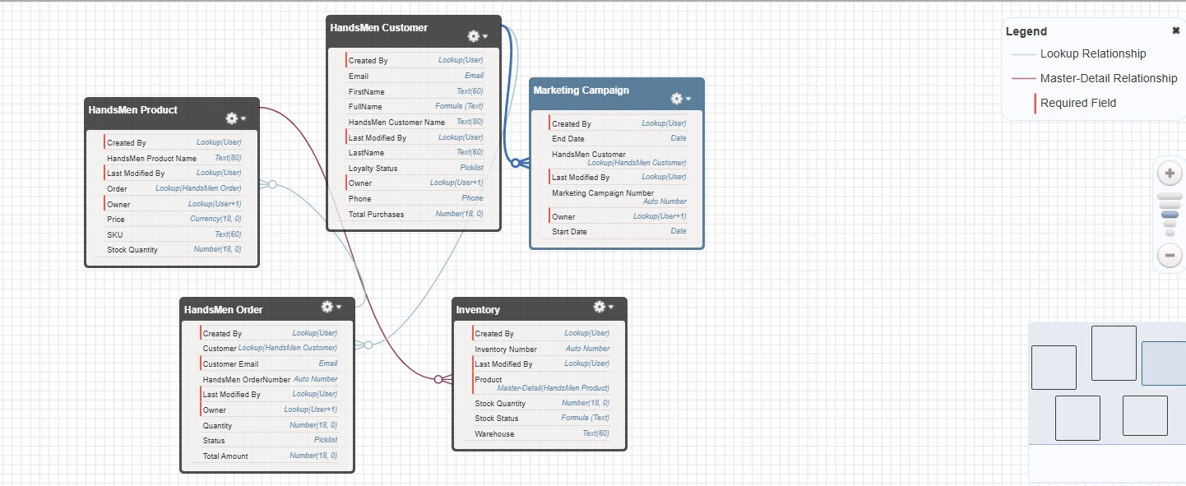
ERD/Data Model

HandsMen Customer
The HandsMen Customer object stores customer-related information such as First Name, Last Name, Email, Phone, Loyalty Status, and Total Purchases.
A Full Name formula field was implemented to automatically combine the customer's first and last names.

HandsMen_Customer Object screenshots:
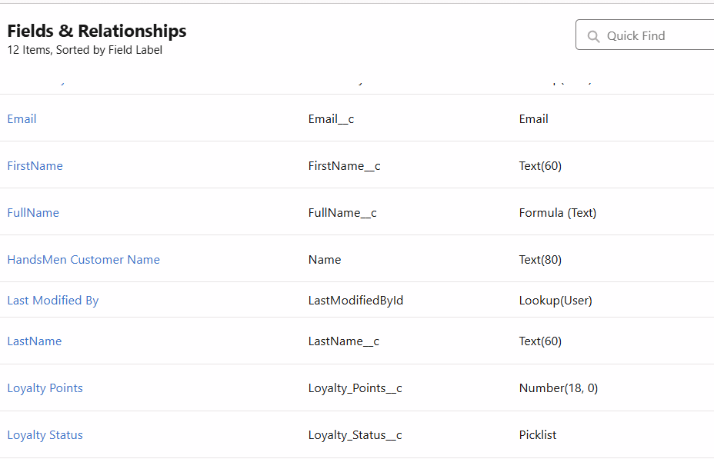

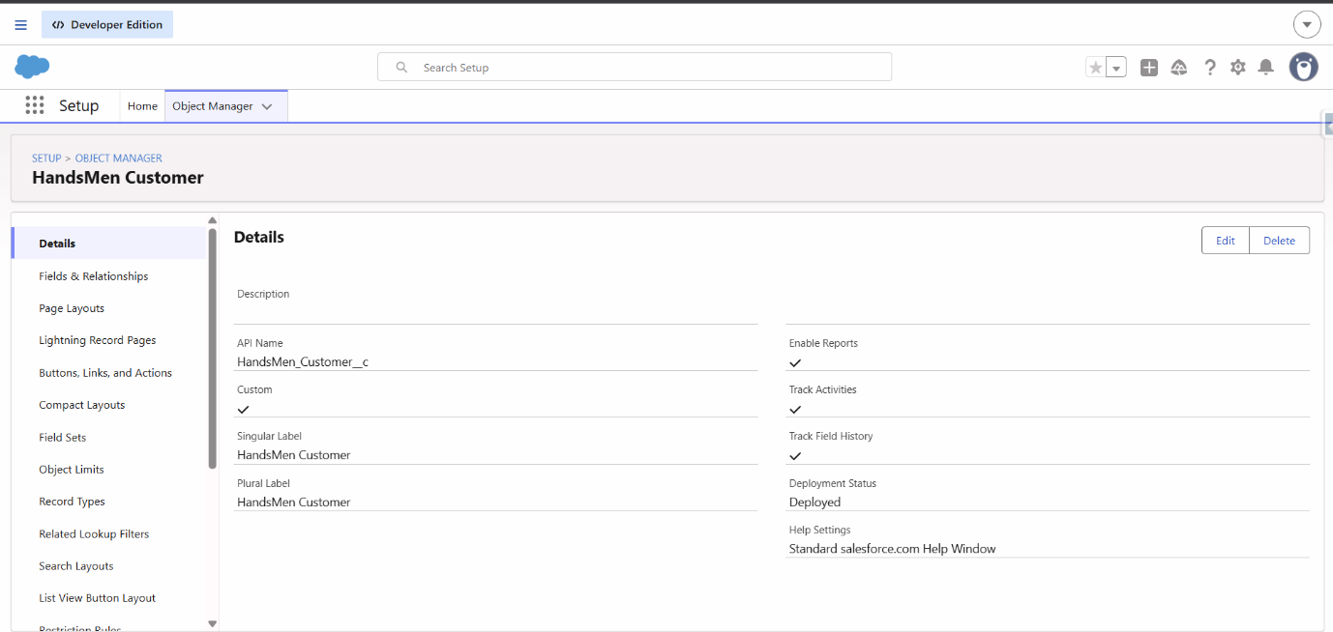

HandsMen Order
The HandsMen Order object stores order-related information including customer, status, quantity, and total amount.
A Lookup relationship connects an order with the corresponding HandsMen Customer.
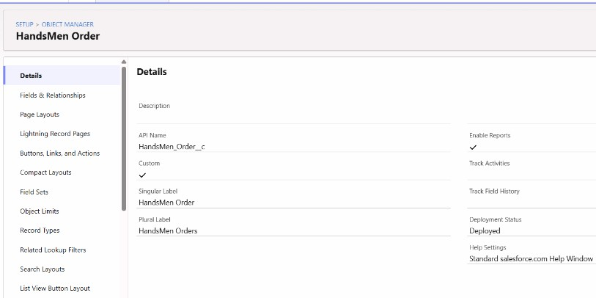
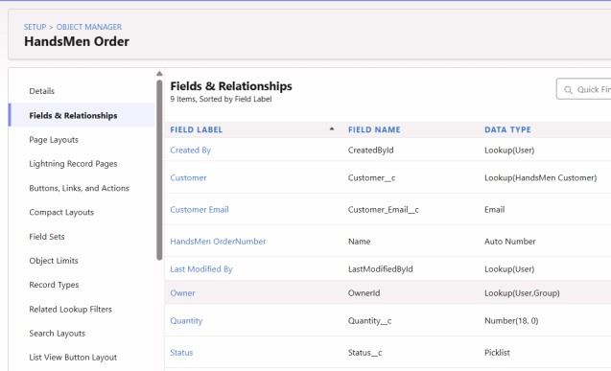
A validation rule was implemented to prevent an order from being saved when the Total Amount is zero or negative. This ensures that invalid financial information cannot be entered into the system.

HandsMen Product
The HandsMen Product object stores product-related information such as product name, price, stock quantity, category, and active status.
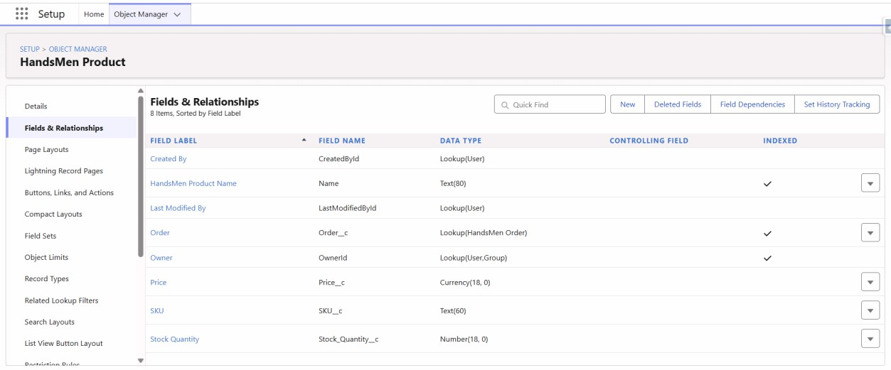
The object is connected with order and inventory information through Salesforce relationships.

Inventory
The Inventory object is responsible for maintaining stock information for products.
Important fields include:
- Product
- Stock Quantity
- Stock Status
A relationship connects inventory records with their corresponding products. A validation rule prevents invalid stock quantities from being entered.
Stock Status Formula
The Stock_Status c formula automatically determines the current stock condition. IF(Stock_Quantity c > 10, "Available", "Low Stock")
The result is:
Stock Quantity > 10 → Available Stock Quantity ≤ 10 → Low Stock
This provides users with an automatically calculated stock status.
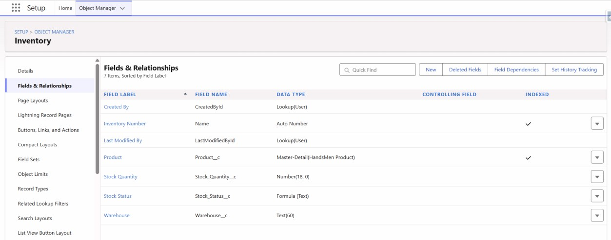

Marketing Campaign
The Marketing Campaign object stores marketing campaign information and maintains its association with customer records.
This allows customer information to be connected with marketing activities within Salesforce.
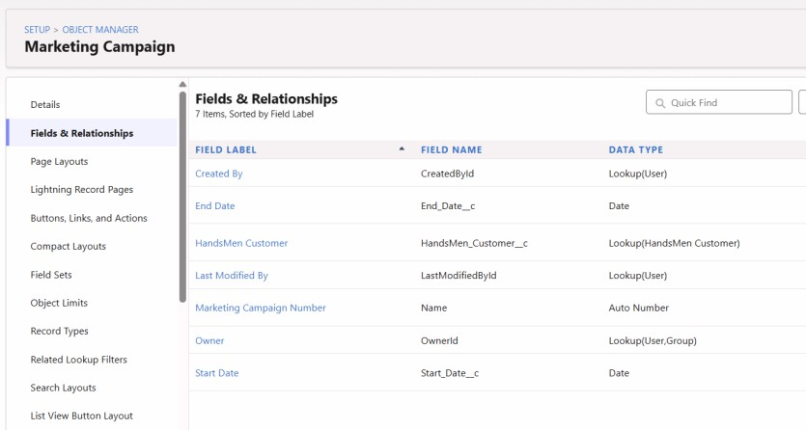

Formulas and Validation Rules

Object | Formula Field | Return Type | Formula
HandsMen Customer | Full Name | Text | FirstName__c + " " + LastName__c
Inventory | Stock Status | Text | IF(Stock_Quantity__c > 10, "Available", "Low Stock")

Object | Rule | Condition | Expected Message
HandsMen Order | Total Amount | Total_Amount__c <= 0 | Please enter a correct amount.
Inventory | Stock Quantity | Stock_Quantity__c <= 0 | Inventory count cannot be less than or equal to zero.
HandsMen Customer | Email | NOT(CONTAINS(Email__c, "@gmail.com")) | Please enter a correct Gmail address.
Formula fields automatically calculate values such as Full Name and Stock Status, reducing manual data entry.
Formula: FirstName c & " " & LastName c
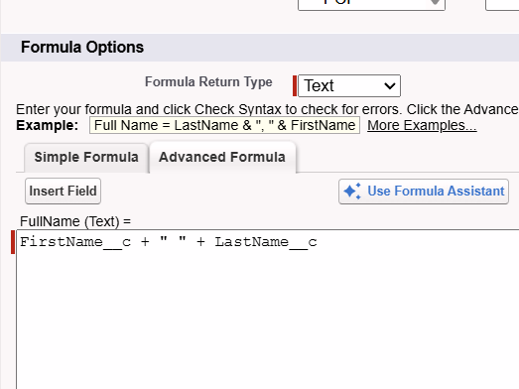

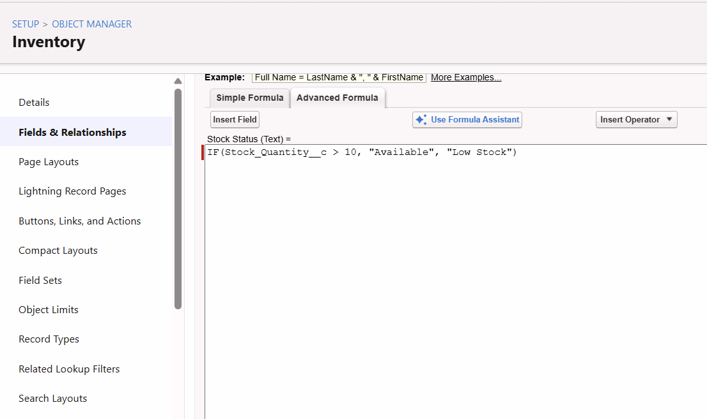

Data Quality
Data quality is maintained through Formula Fields and Validation Rules. The implemented validations prevent:
- Invalid order amounts
- Invalid inventory quantities
- Incorrect customer email formats
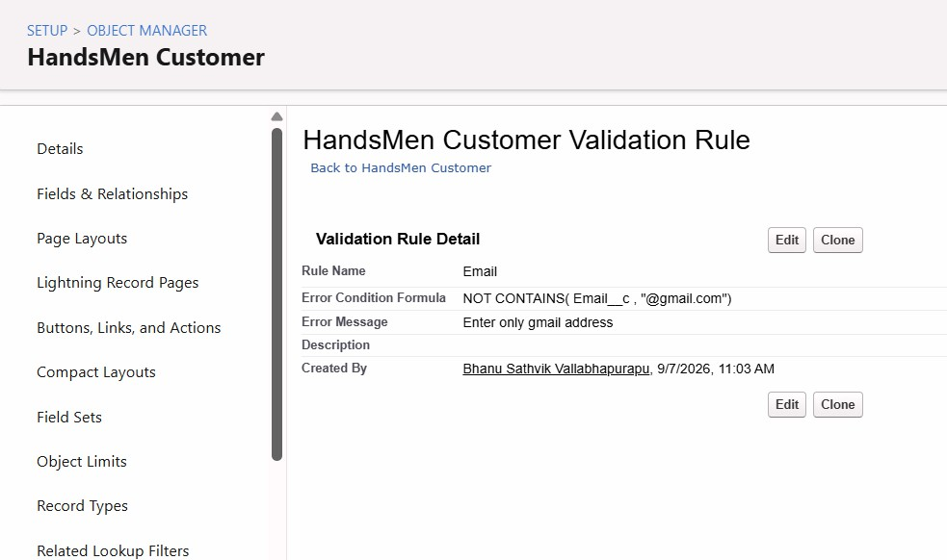
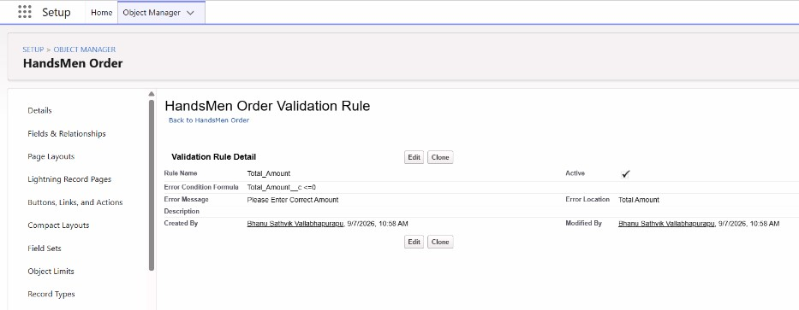
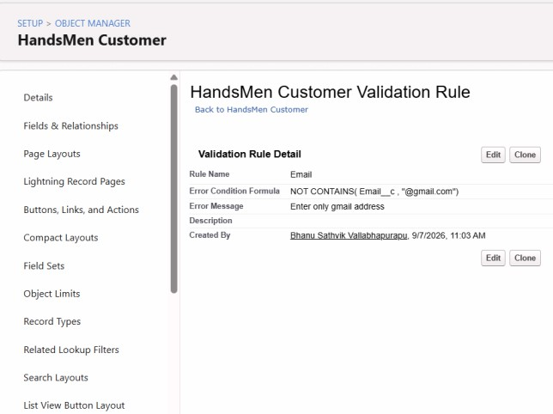

Data Security
The application implements Salesforce security features including:
- Profiles
- Roles
- Role Hierarchy
- Permission Sets
A custom Platform 1 profile was created based on the Standard User profile. Appropriate object permissions were provided for the required HandsMen Threads objects.
The role hierarchy organizes users according to their responsibilities, while the permission set provides additional permissions where required.
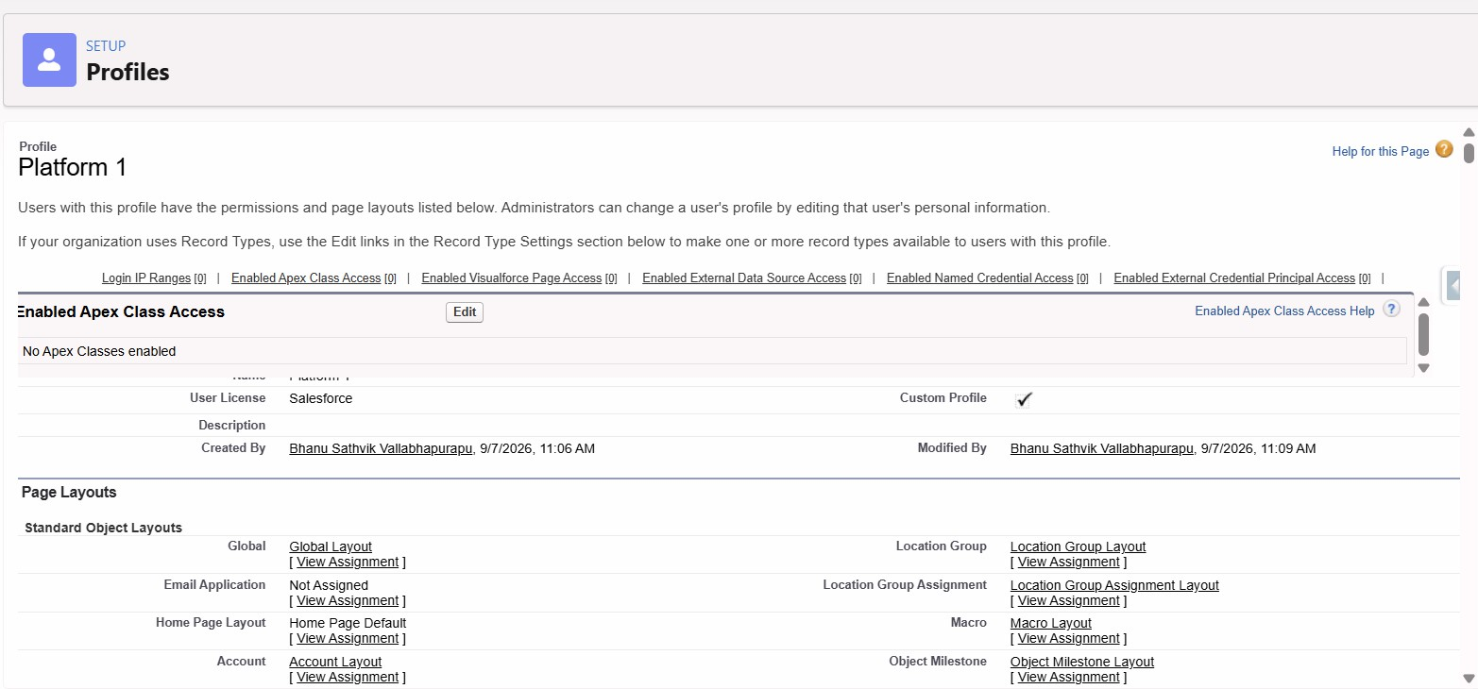
Platform 1 Profile

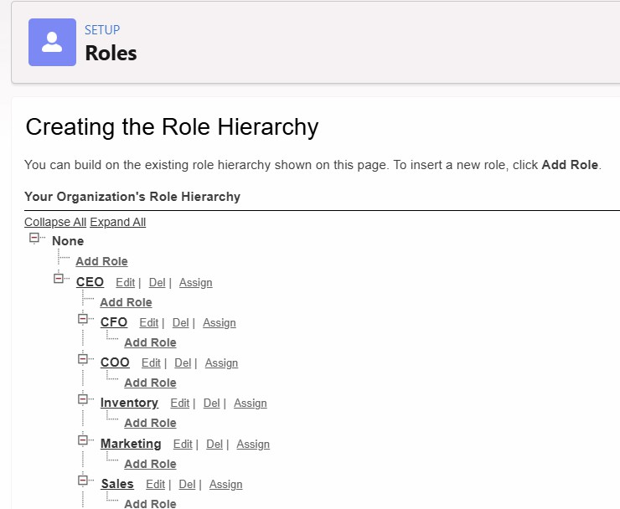

Role Hierarchy

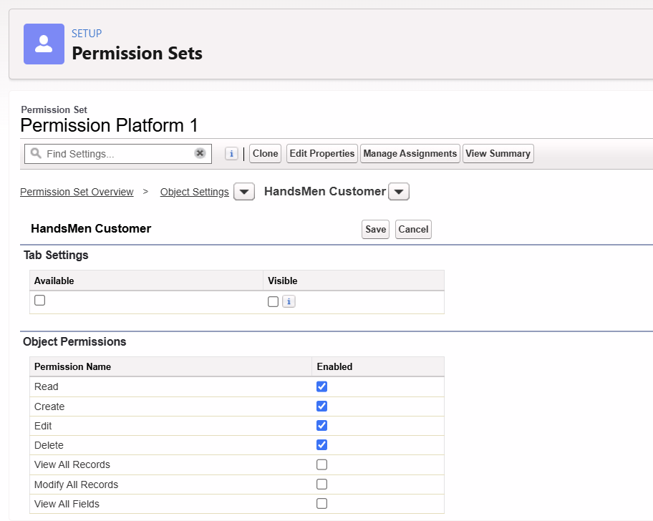
Permission Set

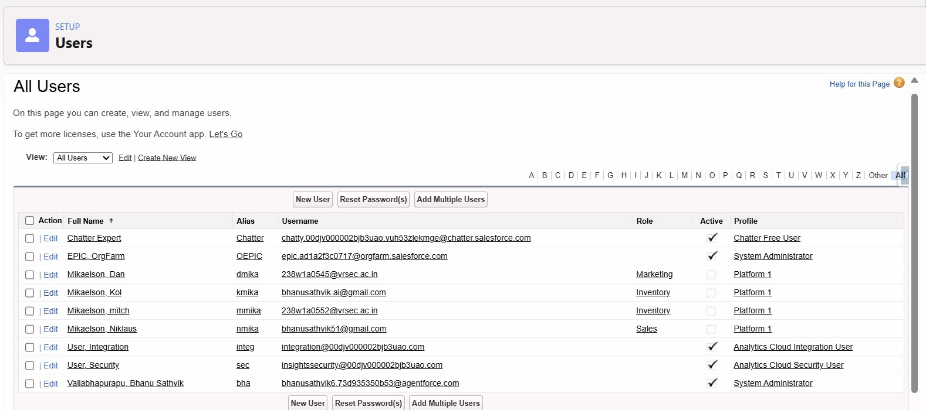
User configuration
The guidelines specifically require Profiles, Roles, Role Hierarchy, Permission Sets, and relevant security configuration to be documented.

Email Templates and Alerts
Template | Type | Used For
Order Confirmation | HTML | Sent when an order changes to Confirmed.
Low Stock Alert | Text | Sent to the inventory team when stock is below five.
Loyalty Program Email | HTML | Supports customer loyalty communication.

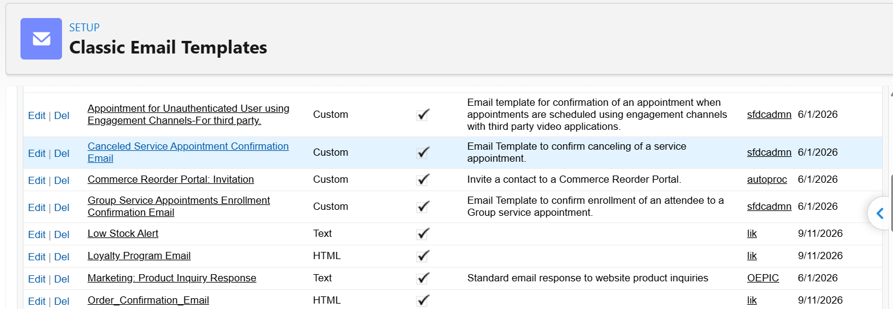

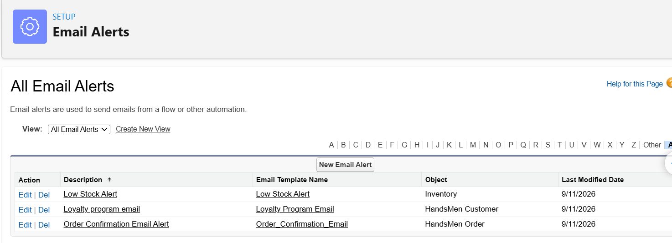

Automation
This will be the main implementation section of your documentation. We can document each automation like this:
Order Confirmation Flow Type: Record-Triggered Flow Object: HandsMen Order Trigger Condition:
Status=Confirmed Functionality:
When an existing order is updated and its status becomes Confirmed, the flow automatically sends the Order Confirmation Email to the customer.
Flow Structure: Order Updated
↓
Status = Confirmed
↓
Order Confirmation Email
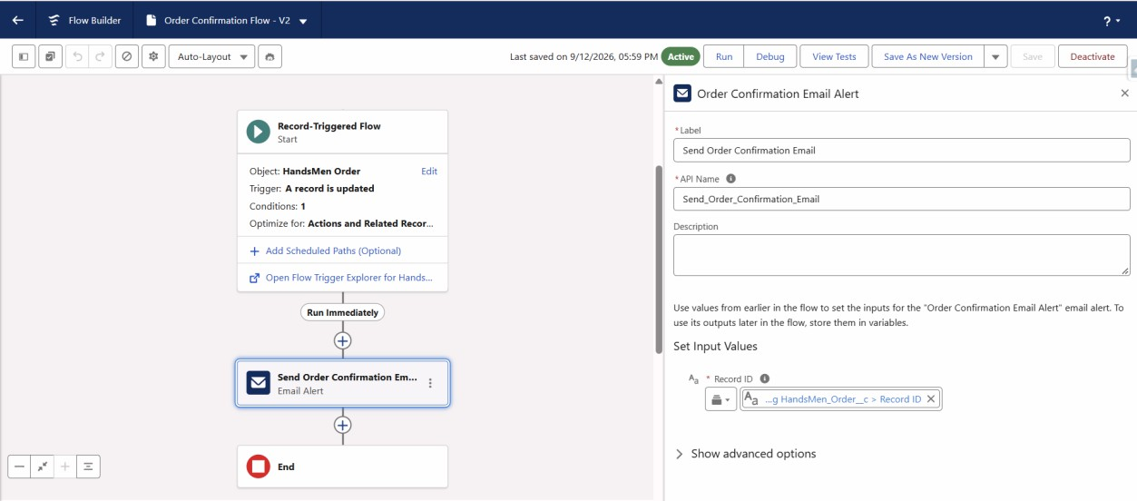

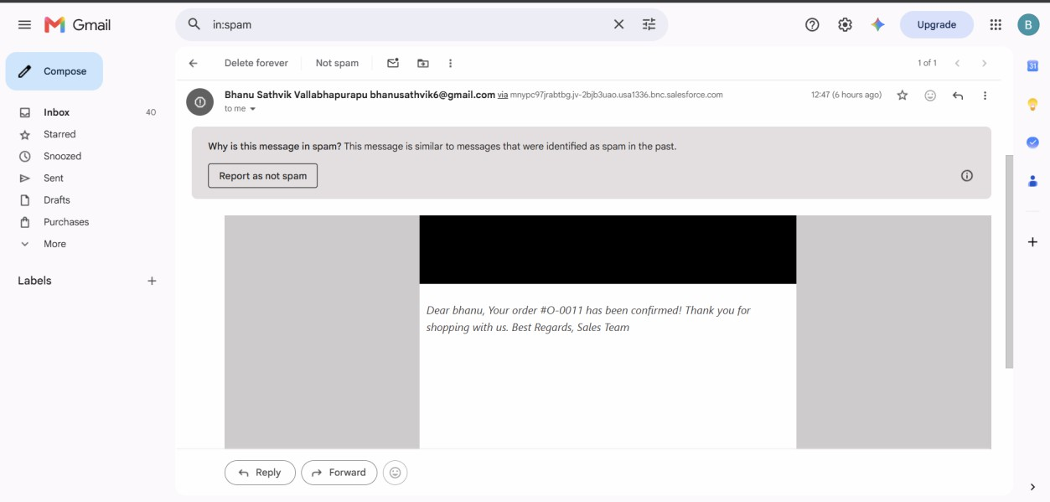

Stock Alert Flow
Type: Record-Triggered Flow Object: Inventory
Trigger Condition:
Stock Quantity < 5 Functionality:
When inventory stock falls below five units, the flow automatically sends a Low Stock Alert to the warehouse team.
Inventory Updated
↓
Stock Quantity < 5
↓
Low Stock Alert Email
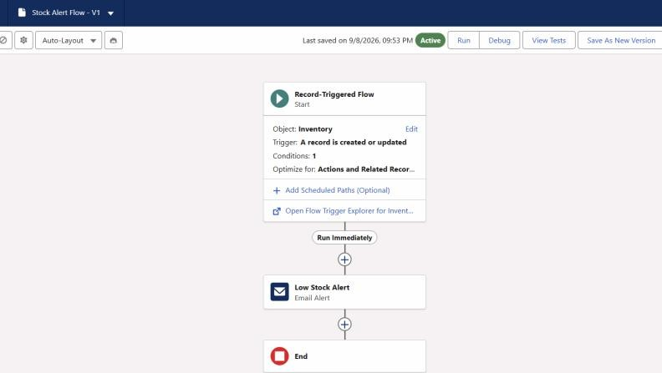

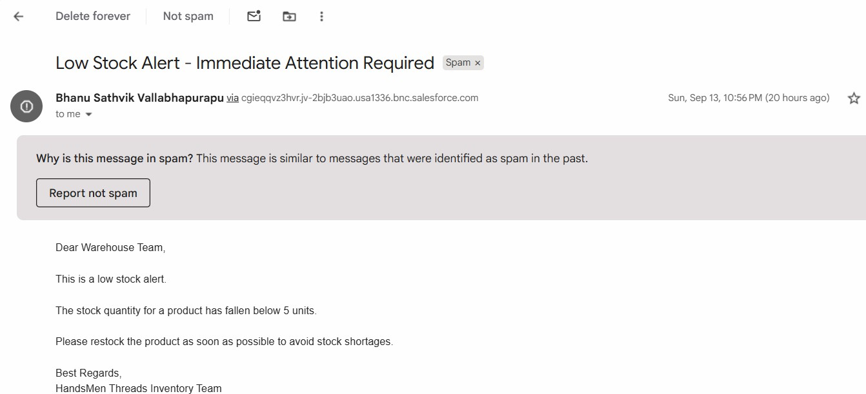

Loyalty Status Flow Type: Scheduled Flow Frequency: Daily Functionality:
The flow evaluates customer purchase history and updates the loyalty status. Total Purchases > 1000 → Gold
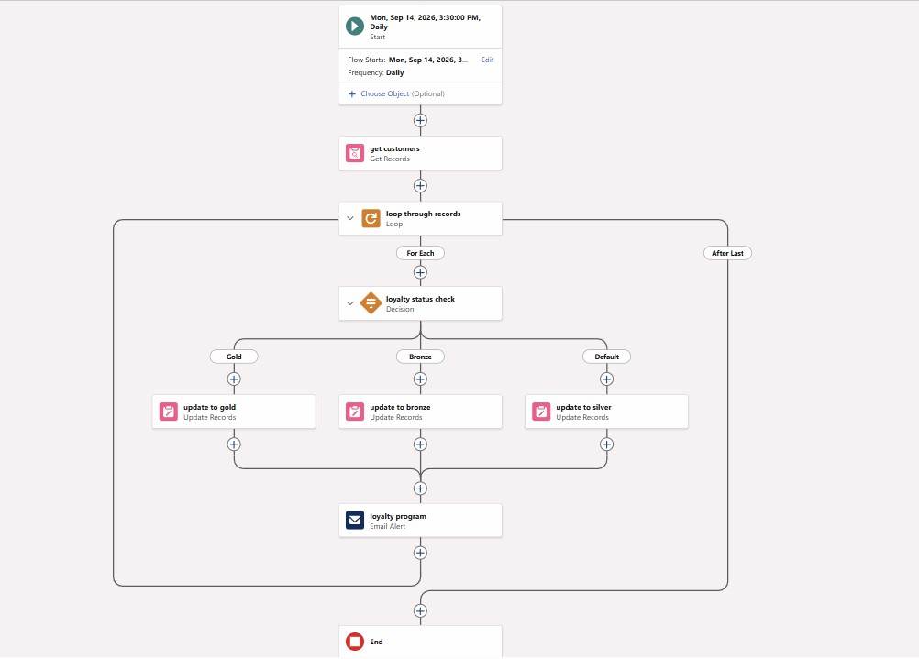
Total Purchases < 500 → Bronze Otherwise → Silver

Apex Trigger
The project uses an Apex Trigger on the HandsMen Order object for business validation.
The trigger executes during before insert and before update operations and invokes the corresponding handler class.
The validation logic is:

Order Status | Required Quantity
Confirmed | > 500
Pending | > 200
Rejection | 0
If an order violates the required condition, the trigger prevents the record from being saved and displays an appropriate error.
Trigger:
trigger OrderTrigger on HandsMen_Order c (before insert, before update) { if (Trigger.isBefore && (Trigger.isInsert || Trigger.isUpdate)) {
OrderTriggerHandler.validateOrderQuantity(Trigger.new);
}
}
Handler:
public class OrderTriggerHandler {
public static void validateOrderQuantity(List<HandsMen_Order c> orderList) { for (HandsMen_Order c order : orderList) {
if (order.Status c == 'Confirmed') {
if (order.Quantity c == null || order.Quantity c <= 500) {
order.Quantity c.addError('For Status "Confirmed", Quantity must be more than 500.');
}
} else if (order.Status c == 'Pending') {
if (order.Quantity c == null || order.Quantity c <= 200) {
order.Quantity c.addError('For Status "Pending", Quantity must be more
than 200.');

}
} else if (order.Status c == 'Rejection') {
if (order.Quantity c == null || order.Quantity c != 0) {
order.Quantity c.addError('For Status "Rejection", Quantity must be 0.');
}
}
}
System.debug('All records validated successfully.');
}
}

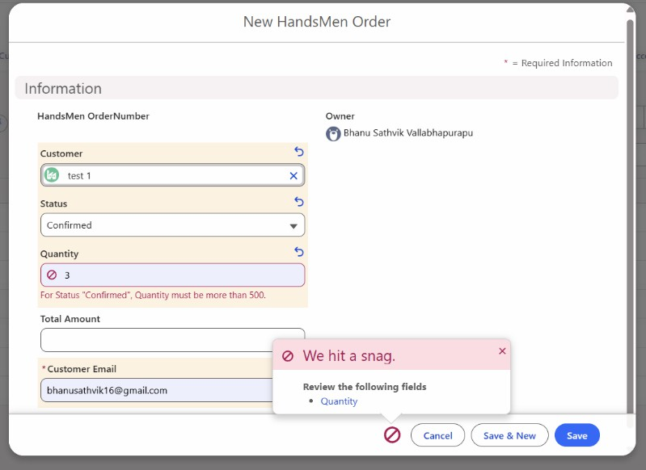

Product Stock Alert Triggger:
trigger ProductStockAlertTrigger on HandsMen_Product__c (after insert, after update) {

List<Messaging.SingleEmailMessage> emails = new List<Messaging.SingleEmailMessage>();

for (HandsMen_Product__c product : Trigger.new) {

Boolean sendAlert = false;

if (Trigger.isInsert) {
if (product.Stock_Quantity__c != null &&
product.Stock_Quantity__c < 5) {
sendAlert = true;
}
}

if (Trigger.isUpdate) {
HandsMen_Product__c oldProduct = Trigger.oldMap.get(product.Id);

if (product.Stock_Quantity__c != null &&
product.Stock_Quantity__c < 5 &&
(oldProduct.Stock_Quantity__c == null ||
oldProduct.Stock_Quantity__c >= 5)) {
sendAlert = true;
}
}
if (sendAlert) {
Messaging.SingleEmailMessage email =
new Messaging.SingleEmailMessage();
email.setToAddresses(
new String[] {UserInfo.getUserEmail()}
);
email.setSubject(
'Low Stock Alert - ' + product.Name
);

email.setPlainTextBody(
'Product: ' + product.Name +
'\nSKU: ' + product.SKU__c +
'\nCurrent Stock: ' + product.Stock_Quantity__c +
'\n\nStock level has fallen below 5 units.'
);
emails.add(email);
}
}
if (!emails.isEmpty()) {
Messaging.sendEmail(emails);
}
}
Customer Layout Trigger

trigger CustomerLoyaltyTrigger on HandsMen_Customer__c (
before insert,
before update
)
{
for (HandsMen_Customer__c customer : Trigger.new) {
Decimal purchases =
customer.Total_Purchases__c == null ? 0 : customer.Total_Purchases__c;
if (purchases > 1000) {
customer.Loyalty_Status__c = 'Gold';
} else if (purchases < 500) {
customer.Loyalty_Status__c = 'Bronze';
} else {
customer.Loyalty_Status__c = 'Silver';
}
}
}
Batch Apex:
The project implements Batch Apex and Scheduled Apex for automated inventory processing.
The Batch Apex class identifies products with stock below 10 units. Stock Quantity < 10
↓
Batch Processing
↓
Add 50 Units
↓
Update Product
The batch is processed in groups of 200 records.
The same class implements Schedulable, allowing the inventory synchronization process to be scheduled to run daily at midnight.

Batch Apex class:
global class InventoryBatchJob implements Database.Batchable<SObject>, Schedulable {
global Database.QueryLocator start(Database.BatchableContext BC) { return Database.getQueryLocator(
'SELECT Id, Stock_Quantity c FROM HandsMen_Product c WHERE Stock_Quantity c < 10'
);
}

global void execute(Database.BatchableContext BC, List<SObject> records) { List<HandsMen_Product c> productsToUpdate = new
List<HandsMen_Product c>();
for (SObject record : records) {
HandsMen_Product c product = (HandsMen_Product c) record; product.Stock_Quantity c += 50; productsToUpdate.add(product);
}
if (!productsToUpdate.isEmpty()) { try {
update productsToUpdate;
} catch (DmlException e) {
System.debug('Error updating inventory: ' + e.getMessage());
}
}
}
global void finish(Database.BatchableContext BC) { System.debug('Inventory Sync Completed');
}
global void execute(SchedulableContext SC) { InventoryBatchJob batchJob = new InventoryBatchJob(); Database.executeBatch(batchJob, 200);
}
}
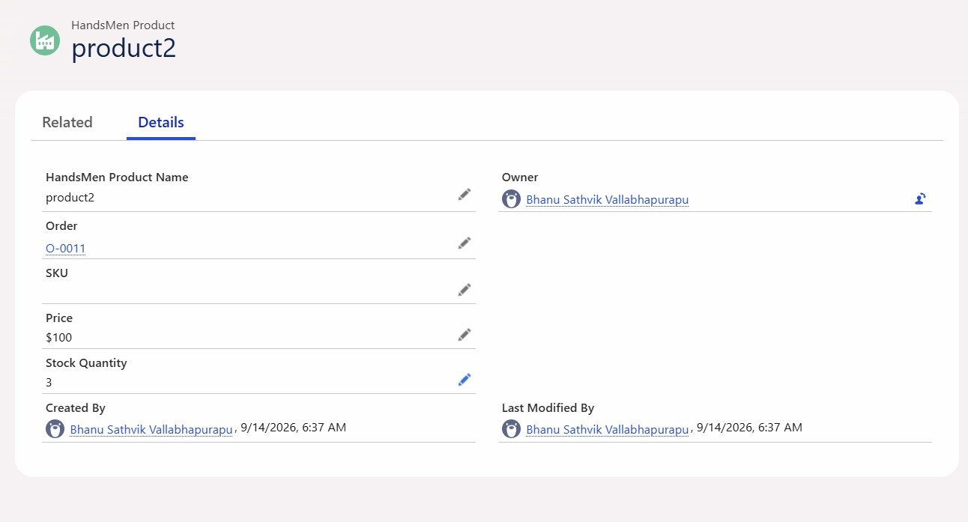
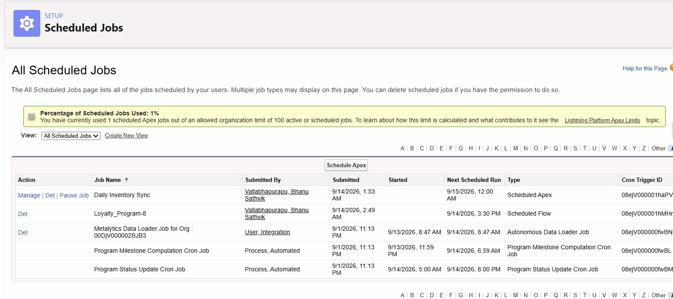

Loyalty Point Batch Job
global class LoyaltyPointsBatchJob implements Database.Batchable<SObject>, Schedulable {

global Database.QueryLocator start(Database.BatchableContext BC) {
return Database.getQueryLocator(
'SELECT Id, Total_Purchases__c, Loyalty_Points__c ' +
'FROM HandsMen_Customer__c'
);
}

global void execute(Database.BatchableContext BC, List<SObject> records) {

List<HandsMen_Customer__c> customersToUpdate =
new List<HandsMen_Customer__c>();

for (SObject record : records) {

HandsMen_Customer__c customer =
(HandsMen_Customer__c) record;

Decimal purchases =
customer.Total_Purchases__c == null
? 0
: customer.Total_Purchases__c;

customer.Loyalty_Points__c =
Math.floor(purchases / 100);

customersToUpdate.add(customer);
}

if (!customersToUpdate.isEmpty()) {
update customersToUpdate;
}
}

global void finish(Database.BatchableContext BC) {
System.debug('Loyalty Points Calculation Completed');
}

global void execute(SchedulableContext SC) {
LoyaltyPointsBatchJob batchJob =
new LoyaltyPointsBatchJob();

Database.executeBatch(batchJob, 200);
}
}

Testing

Feature | Test Input | Expected Result | Actual Result
Full Name Formula | Bhanu + Sathvik | Bhanu Sathvik | Passed
Stock Status | Stock = 5 | Low Stock | Passed
Order Validation | Amount = 0 | Record rejected | Passed
Order Confirmation | Status → Confirmed | Email sent | Passed
Stock Alert | Stock → 4 | Alert email sent | Passed
Loyalty Flow | Purchases = 1500 | Gold | Passed
Apex Trigger | Confirmed + Qty 300 | Record rejected | Passed
Batch Apex | Stock = 5 | Stock = 55 | Passed

All the screenshots regarding the testing are pasted previous sections

- Conclusion
The HandsMen Threads Salesforce CRM successfully provides a centralized solution for managing customer, order, product, inventory, and marketing information. The implementation combines Salesforce configuration with declarative and programmatic automation to improve data quality and business efficiency.
The implemented Formula Fields and Validation Rules improve data accuracy, while Profiles, Roles, and Permission Sets provide controlled access to business data. Record-Triggered Flows automate customer communication and inventory alerts, while Scheduled Flows manage loyalty status updates. Apex Triggers provide additional business validation, and Batch Apex automates large-scale inventory processing.
The project demonstrates how Salesforce can be used to build a scalable CRM solution that reduces manual work, improves operational accuracy, and enhances customer service.

